ML Challenge 2025: Smart Product Pricing Solution
Team Name: Hack Club
Team Members: Pushkar Gupta, Lakshya Tripathi, Akshat Srivastava, Sachin Vaishnav
Submission Date: October 13, 2025

1. Executive Summary
We implemented a multimodal ML solution to predict product prices by combining text and image embeddings. Text features are derived using Sentence Transformers, while visual features are extracted via EfficientNet-B0. These embeddings are fused into a LightGBM regressor trained on log-transformed targets, achieving robust and stable price predictions. Performance is evaluated using SMAPE, ensuring consistent accuracy across price ranges.

2. Methodology Overview
The objective is to predict product prices from text and image data using a multimodal learning approach. We analyzed 75K training samples with varied price distributions and heterogeneous descriptions.
Key Observations:
- High variance in prices; applying log transformation stabilizes target distribution.
- Text reveals brand, specs, and quantity cues vital for pricing.
- Images indicate product quality, packaging, and brand visual cues.
- Combining both modalities improves overall model accuracy.
- SMAPE metric suits percentage-based error evaluation.
Approach Type: Multimodal Feature Fusion with Gradient Boosting.
Innovation: Unified pipeline using SentenceTransformer + EfficientNet embeddings → concatenated → LightGBM regression.

3. Model Architecture

3.1 Architecture Overview
The architecture below integrates text and image embeddings before regression:
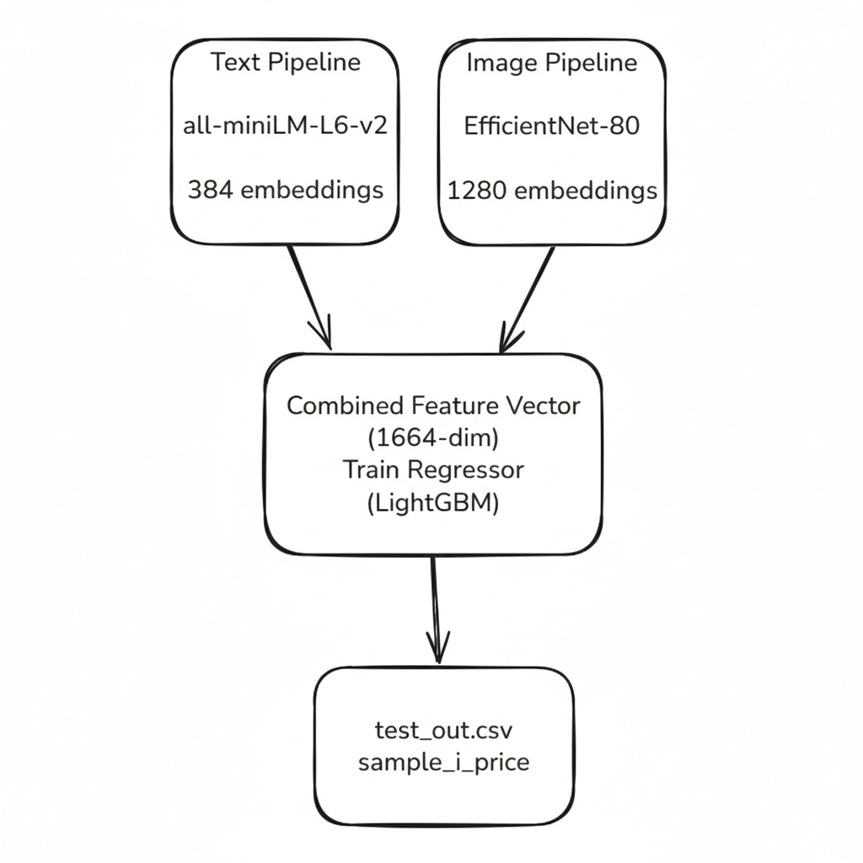

3.2 Model Components
Text Processing:
- Cleaning: lowercase, punctuation removal, whitespace normalization.
- Model: Sentence Transformers (all-MiniLM-L6-v2).
- Output: 384-dim embeddings.
Image Processing:
- Preprocessing: resize 224×224, normalize to ImageNet stats.
- Model: EfficientNet-B0 (pre-trained, frozen weights).
- Output: 1280-dim embeddings.
Regression Pipeline:
- Fusion: concatenate text+image features (1664-dim).
- Target: log1p(price) to reduce skew.
- Model: LightGBM with early stopping.
- Evaluation Metric: SMAPE.

4. Model Performance
Train/Validation Split: 85% / 15%
Input Dim: 1664 (384 text + 1280 image)
Model: LightGBM Regressor
Hyperparameters: lr=0.08, num_leaves=63, feature_fraction=0.7, bagging_fraction=0.7
Validation SMAPE: 56.70
The LightGBM regressor achieved stable convergence and lower SMAPE after log-target transformation. Cross-validation confirmed consistent performance across price ranges.

5. Conclusion
Our multimodal pipeline successfully captures both semantic and visual aspects of products. Text embeddings enrich contextual understanding while image embeddings capture brand and packaging cues. Combined via LightGBM regression, this architecture generalizes well across diverse product categories. Future improvements include fine-tuning image encoders and leveraging ensemble stacking.

Appendix
A. Code Artefacts:
https://drive.google.com/drive/folders/1K7IfoXGg0wDQ4jcJi-Mqsf_sqH4w_NGF?usp=sharing
B. Additional Results:
- Embedding extraction progress and logs.
- Validation and test prediction summaries.
- Training curve snapshots and parameter tuning history.

